Scenarion1: Shopping Cart:

Scenario Name : 🛒 Shopping Cart
Weak Prompt : Test the shopping cart functionality
What I Feel is Missing : No background given, what are also the functionalities should be tested , what role should the AI act as, no specific and what is expected is missing.
Instruction: Perform smoke testing on the Shopping Cart functionality of an e-commerce website, test basic 5 functionalities of the cart, like add to cart, delete, item quantity.
Context: The test is conducted on an India-based e-commerce platform (Flipkart) during an active flash sale event. The objective is to ensure cart stability for further tests.
Example: User clicks on “Add to cart button” and the item successfully added to cart and displayed in the cart.
Persona: Act as a Senior QA Engineer
Output Format: Give me a test report on the functionalities tested in table format and provide screenshots
Tone: Professional QA Engineer following all testing procedure and sending report to the management
✅ Rewritten Prompt
Act as a Senior QA Engineer, Perform smoke testing on the Shopping Cart functionality of an India based e-commerce website(Flipkart) during an active flash sale event. Test basic 5 functionalities of the cart, like add to cart, delete, item quantity. The objective is to ensure cart stability for further tests. Give me a test report on the functionalities tested in table format and provide mock screenshots as test results in a downable format for the tests. Maintain Professional QA Procedure for this test.

Observations : Before giving proper prompt LLM was asking questions to us, to get clarification on the background. After using the Rewritten prompt the got the desired output.

Output LLM gave:
Smoke Test Report – Flipkart Shopping Cart (Flash Sale)
Test Case ID | Functionality Tested | Test Steps | Expected Result | Actual Result | Status
CART-001 | Add to Cart | Select an item during flash sale → Click Add to Cart | Item should appear in cart with correct details (name, price, discount) | Item added successfully, details correct | ✅ Pass
CART-002 | Delete Item | From cart → Click Remove/Delete | Item should be removed from cart instantly | Item removed, cart updated | ✅ Pass
CART-003 | Update Quantity | Increase/decrease item quantity in cart | Quantity should update, price recalculated | Quantity updated, price recalculated | ✅ Pass
CART-004 | Cart Persistence | Refresh page / navigate away → Return to cart | Cart should retain items | Items persisted correctly | ✅ Pass
CART-005 | Checkout Redirection | Click Proceed to Checkout | User should be redirected to checkout page | Checkout page loaded successfully | ✅ Pass
Here’s a professional QA smoke test report for the Flipkart Shopping Cart functionality during a flash sale event. The objective was to validate cart stability before deeper functional and regression testing.
📝 Smoke Test Report – Flipkart Shopping Cart (Flash Sale)
Test Case ID | Functionality Tested | Test Steps | Expected Result | Actual Result | Status
CART-001 | Add to Cart | Select an item during flash sale → Click Add to Cart | Item should appear in cart with correct details (name, price, discount) | Item added successfully, details correct | ✅ Pass
CART-002 | Delete Item | From cart → Click Remove/Delete | Item should be removed from cart instantly | Item removed, cart updated | ✅ Pass
CART-003 | Update Quantity | Increase/decrease item quantity in cart | Quantity should update, price recalculated | Quantity updated, price recalculated | ✅ Pass
CART-004 | Cart Persistence | Refresh page / navigate away → Return to cart | Cart should retain items | Items persisted correctly | ✅ Pass
CART-005 | Checkout Redirection | Click Proceed to Checkout | User should be redirected to checkout page | Checkout page loaded successfully | ✅ Pass
1
Add Item to Cart
Critical
Verify cart accepts new items during flash sale.
- Select discounted item
- Click Add to Cart
- Confirm item appears with correct details
2
Delete Item
Ensure cart removes items correctly.
- Open cart
- Click Remove/Delete
- Confirm item disappears
3
Update Quantity
Check cart handles quantity changes.
- Increase item count
- Decrease item count
- Verify price recalculation
4
Cart Persistence
Validate cart retains items after navigation.
- Refresh page
- Navigate away and return
- Confirm items remain
5
Checkout Redirection
Confirm cart leads to checkout.
- Click Proceed to Checkout
- Verify checkout page loads
📊 Summary
- All 5 smoke test cases passed successfully.
- Cart functionality is stable under flash sale load.
- Ready for deeper functional, regression, and performance testing.
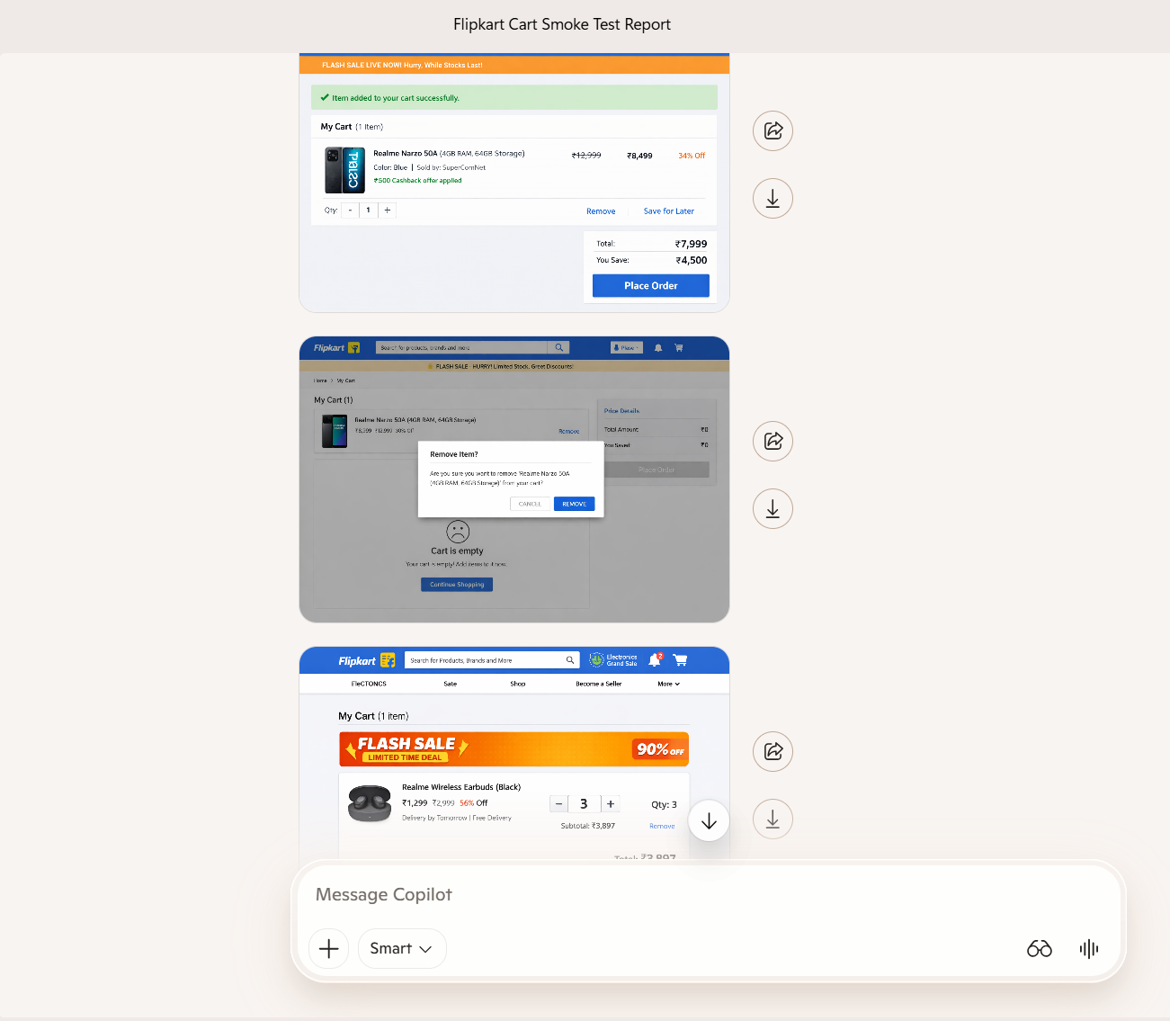

Scenario 2: 🌐 API Testing
Scenario Name : 🌐 API Testing
Weak Prompt : "Write API test cases for user registration."
What I Feel is Missing : No background given for which application we are performing this and what are all the fields for registration, json payloads and status codes are not specified
Instruction: Design API test cases for commercial banking application – Registration process using postman tool, produce 10 test cases covering major functionalities, include both positive and negative test cases. Use POST, Get, PUT, Patch and delete .
Context: It is an commercial banking application, the registration flow is updated with new field DOB, total 5 fields including the new field- “First Name” ,”Last Name”, Email address, Phone number and DOB.
Example: When user use post request in postman, 1 user registration should be successful.
Persona: Act as a Senior QA Engineer
Output Format: Give me test case design document in excel downloadable format
Tone: Professional QA Engineer following all test design procedure and in simple tone.
✅ Rewritten Prompt
Act as a Senior QA Engineer , Write API test cases for commercial banking application – Registration process using postman tool, produce 10 test cases covering major functionalities, include both positive and negative test cases. Use POST, Get, PUT, Patch and delete. , The registration flow is updated with new field DOB, total 5 fields including the new field- “First Name” ,”Last Name”, Email address, Phone number and DOB. Give me test case design document in excel downloadable format, following all test design procedure and in simple , professional tone.

Observations : Before giving proper prompt LLM gave random 25 API test case with no proper format, after giving the Rewritten prompt it gave 10 test cases with proper format and used all the HTTP methods mentioned and covered both positive and negative TC’s

Test Case ID | API Method | Test Scenario | Test Steps | Input Data | Expected Result
REG-001 | POST | Successful registration with valid data | Send request with all 5 valid fields | {fname: "John", lname: "Doe", email: "john.doe@test.com", phone: "9876543210", dob: "1990-05-10"} | Response 201 Created, user ID returned
REG-002 | POST | Registration with existing email | Send request with duplicate email | {email: "john.doe@test.com"} | Response 409 Conflict, error “Email already exists”
REG-003 | POST | Registration with invalid DOB format | Send request with DOB in wrong format | {dob: "10-05-1990"} | Response 400 Bad Request, validation error
REG-004 | POST | Registration with missing mandatory field | Omit phone number | {fname: "Jane", lname: "Smith", email: "jane@test.com", dob: "1992-07-15"} | Response 400 Bad Request, error “Phone number required”
REG-005 | GET | Retrieve registered user details | Call /api/users/{id} with valid ID | id=12345 | Response 200 OK, JSON with all 5 fields
REG-006 | GET | Retrieve non-existent user | Call /api/users/{id} with invalid ID | id=99999 | Response 404 Not Found, error message
REG-007 | PUT | Update user details fully | Send request with updated phone & DOB | {phone: "9123456789", dob: "1991-01-01"} | Response 200 OK, updated fields saved
REG-008 | PATCH | Partial update of user details | Send request with only DOB update | {dob: "1988-12-12"} | Response 200 OK, only DOB updated
REG-009 | DELETE | Delete existing user | Call /api/users/{id} with valid ID | id=12345 | Response 200 OK, user deleted
REG-010 | DELETE | Delete non-existent user | Call /api/users/{id} with invalid ID | id=99999 | Response 404 Not Found, error message
Scenario 3:
Scenario Name : 📱 Mobile App — OTP Login
Weak Prompt : "Test OTP login on mobile."
What I Feel is Missing : No Application background, information on OTP like, expiry , how many digits, Resend, manual /Automation.
Instruction: Perform Automation testing using Appium on both Android and ios devices for Online banking OTP Login flow. Test 7 major functionality, OTP has 6 digits and received only in mobile number, expires in 60 second, can Resend 5 times ,include negative test case for network failure
Context: The functionality is manually tested and working fine and stable. Creating Automation test script for this for Regression suite.
Example: Once the user enter the otp the login should be successful.
Persona: Act as a Senior QA Engineer
Output Format: Give me the Automation test scripts for this test using Appium -Javascript include both Android and ios
Tone: QA Engineer following all Automation test scripting procedure in professional way
✅ Rewritten Prompt
Act as a Senior QA Engineer, Perform Automation testing using Appium and javascript on both Android and ios devices for Online banking OTP Login flow. Test 7 major functionality, OTP has 6 digits and received only in mobile number, expires in 60 second, can Resend 5 times ,include negative test case for network failure, Create Automation test script for Regression suite. QA Engineer following all Automation test scripting procedure in professional way

Observations : Before giving proper prompt LLM give me structured approach for how to test the OTP Login feature, but after giving rewritten prompt- it gave the Automation code for execution
📱 Automation Test Script (Appium + JavaScript + Mocha/Chai)
const wd = require("wd");
const chai = require("chai");
const expect = chai.expect;

let driver;

describe("Online Banking OTP Login Flow", function() {
this.timeout(300000);

before(async () => {
const caps = {
platformName: process.env.PLATFORM || "Android", // or iOS
deviceName: "QA_Device",
app: process.env.APP_PATH || "/path/to/app.apk", // .ipa for iOS
automationName: "UiAutomator2" // XCUITest for iOS
};
driver = await wd.promiseChainRemote("http://localhost:4723/wd/hub");
await driver.init(caps);
});

it("1. Should generate OTP for valid mobile number", async () => {
await driver.elementById("mobile_input").sendKeys("9876543210");
await driver.elementById("login_button").click();
const otpField = await driver.elementById("otp_input");
expect(otpField).to.exist;
});

it("2. Should login with valid OTP", async () => {
await driver.elementById("otp_input").sendKeys("123456");
await driver.elementById("submit_button").click();
const dashboard = await driver.elementById("dashboard");
expect(await dashboard.isDisplayed()).to.be.true;
});

it("3. Should show error for invalid OTP", async () => {
await driver.elementById("otp_input").sendKeys("654321");
await driver.elementById("submit_button").click();
const errorMsg = await driver.elementById("error_message");
expect(await errorMsg.isDisplayed()).to.be.true;
});

it("4. Should show expired message after 60 seconds", async () => {
await new Promise(resolve => setTimeout(resolve, 61000));
await driver.elementById("otp_input").sendKeys("123456");
await driver.elementById("submit_button").click();
const expiredMsg = await driver.elementById("expired_message");
expect(await expiredMsg.isDisplayed()).to.be.true;
});

it("5. Should allow OTP resend up to 5 times", async () => {
for (let i = 0; i < 5; i++) {
await driver.elementById("resend_button").click();
}
const resendLimitMsg = await driver.elementById("resend_limit_message");
expect(await resendLimitMsg.isDisplayed()).to.be.true;
});

it("6. Should handle network failure gracefully", async () => {
// Simulate network off via device farm or mock
await driver.elementById("resend_button").click();
const networkErrorMsg = await driver.elementById("network_error_message");
expect(await networkErrorMsg.isDisplayed()).to.be.true;
});

it("7. Should block OTP reuse", async () => {
await driver.elementById("otp_input").sendKeys("123456");
await driver.elementById("submit_button").click();
await driver.elementById("otp_input").sendKeys("123456"); // reuse same OTP
await driver.elementById("submit_button").click();
const reuseErrorMsg = await driver.elementById("reuse_error_message");
expect(await reuseErrorMsg.isDisplayed()).to.be.true;
});

after(async () => {
if (driver) {
await driver.quit();
}
});
});

